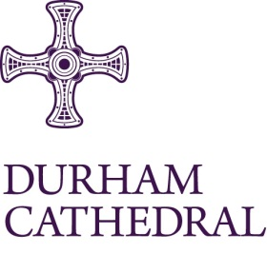
Vacancy for Tenor Lay Clerk

Job Title: Lay Clerk (Tenor)

Location: Durham Cathedral

Status: Permanent

Hours: 14.50 hours per week

Salary: £11,974.00 per annum

Durham Cathedral Choir consists of up to 48 Choristers, (boys and girls singing in alternation), 6 Choral Scholars and 6 Lay Clerks. The Choir sings the daily Cathedral services during Choir term. The Choir performs a wide, exciting and varying repertoire extending from plainsong works written in Durham eight centuries ago to works written in the last ten years, including works commissioned especially for the Cathedral. It also appears regularly in concerts, in both the Cathedral and elsewhere. The Choir also tours from time to time.

Durham, with its thriving University, its magnificent setting, and its historic background has much to offer as a place to settle: a busy musical and cultural life, with Newcastle very close (14 miles), and such centres as York, Edinburgh and London all quickly reached by train. The Cathedral Choir is a happy and sociable team whose comradeship extends well outside the Choir stalls.

Undergraduate students are not normally eligible for Lay Clerkship; they are welcome to apply for Choral Scholarships as and when such Scholarships become available.

Safeguarding – this post is subject to completion of a confidential self-declaration form and an Enhanced DBS Check with Children’s Barred List. This post involves Regulated Activity with children. Safer Recruitment – in line with the Cathedral’s Safer Recruitment procedures, applicants must be willing and able to undergo the relevant pre-employment checks including proof of eligibility to work in the UK, a full and complete employment history (including any breaks in employment) and satisfactory references.

Durham Cathedral is committed to safeguarding. Safeguarding is everyone’s responsibility. For further details, please refer to our Safeguarding Policy Statement.

For an application pack please go to: https://www.durhamcathedral.co.uk/about-us/jobs

Closing date for receipt of completed application form: 9am Monday 16 March 2026
Shortlisting date: Monday 16 March 2026
Interview date: Tuesday 24 March 2026 at Durham Cathedral
Preferred start date: By arrangement, but no later than Monday 01 September 2026

