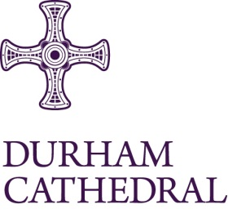

Vacancy for Event Team Lead

Job Title: Event Team Lead

Location: Durham Cathedral

Contract: Permanent

Hours of Work: Hours as required by business needs

Rate of Pay: £14.70 per hour

An exciting opportunity has arisen for an Event Team Lead to join the team at Durham Cathedral to support in the preparation and delivery of events.

You will be highly motivated, have excellent people and customer service skills with relevant demonstrable experience of managing events and organising a team.

In line with Durham Cathedral’s Safer Recruitment procedures, applicants must be willing and able to undertake relevant pre-employment checks including proof of eligibility to work in the UK, a full and complete employment history (including any breaks in employment), satisfactory references and a Disclosure and Barring Service (DBS) check at Basic level. In addition the post-holder will be required to gain a Personal Licence to support in the operation of delivering hospitality.

In addition the post-holder will be required to gain a Personal Licence to support in the operation of delivering hospitality.

Closing date for receipt of completed application forms is Monday 21 July 2025 at 9am.

Interviews will be held on Monday 28 July 2025 at Durham Cathedral.

For a candidate application pack which includes full details about the above post please go to:
https://www.durhamcathedral.co.uk/about-us/jobs

