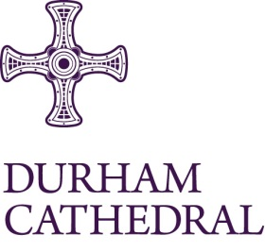

Vacancy for Event Team Lead

Job Title: Relief Events Assistant

Location: Durham Cathedral

Contract: Permanent

Hours of Work: Hours as required by business needs.

Rate of Pay: £12.60 per hour

An exciting opportunity has arisen for a Relief Events Assistant to join the team at Durham Cathedral to support in the preparation and delivery of events. The Relief Events Assistant will help support the Visitor Experience Team to ensure an exceptional visitor experience.

You will be highly motivated, have excellent people and customer service skills with relevant demonstrable experience of managing events and organising a team.

In line with Durham Cathedral’s Safer Recruitment procedures, applicants must be willing and able to undertake relevant pre-employment checks including proof of eligibility to work in the UK, a full and complete employment history (including any breaks in employment), satisfactory references and a Disclosure and Barring Service (DBS) check at Basic level.

Closing date for receipt of completed application forms is Monday 21 July 2025 at 9am.

Interviews will be held on Monday 28 July 2025 at Durham Cathedral.

For a candidate application pack which includes full details about the above post please go to:
https://www.durhamcathedral.co.uk/about-us/jobs

